1• https://www.hackerrank.com/challenges/sql-projects/problem?isFullScreen=true

Answer:

WITH a

AS (SELECT DISTINCT Row_number() OVER ( ORDER BY start_date) project_id, start_date FROM projects

WHERE start_date NOT IN (SELECT end_date FROM projects)

ORDER BY start_date),

b AS (SELECT DISTINCT Row_number() OVER ( ORDER BY end_date) project_id, end_date FROM projects WHERE end_date NOT IN (SELECT start_date FROM projects) ORDER BY end_date) SELECT start_date, end_date FROM a INNER JOIN b using (project_id) ORDER BY ( end_date – start_date ), start_date;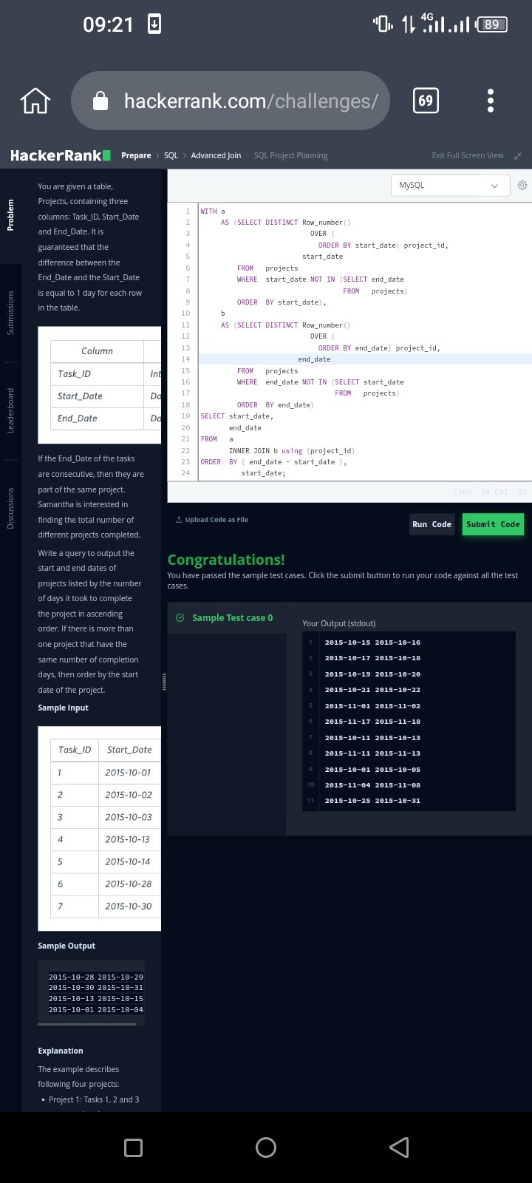

2• https://leetcode.com/problems/delete-duplicate-emails/?envType=list&envId=e97a9e5m

Answer:

Delete P2

FROM Person p1, Person p2

WHERE P1.Email = P2.Email

And P1.id<P2.id;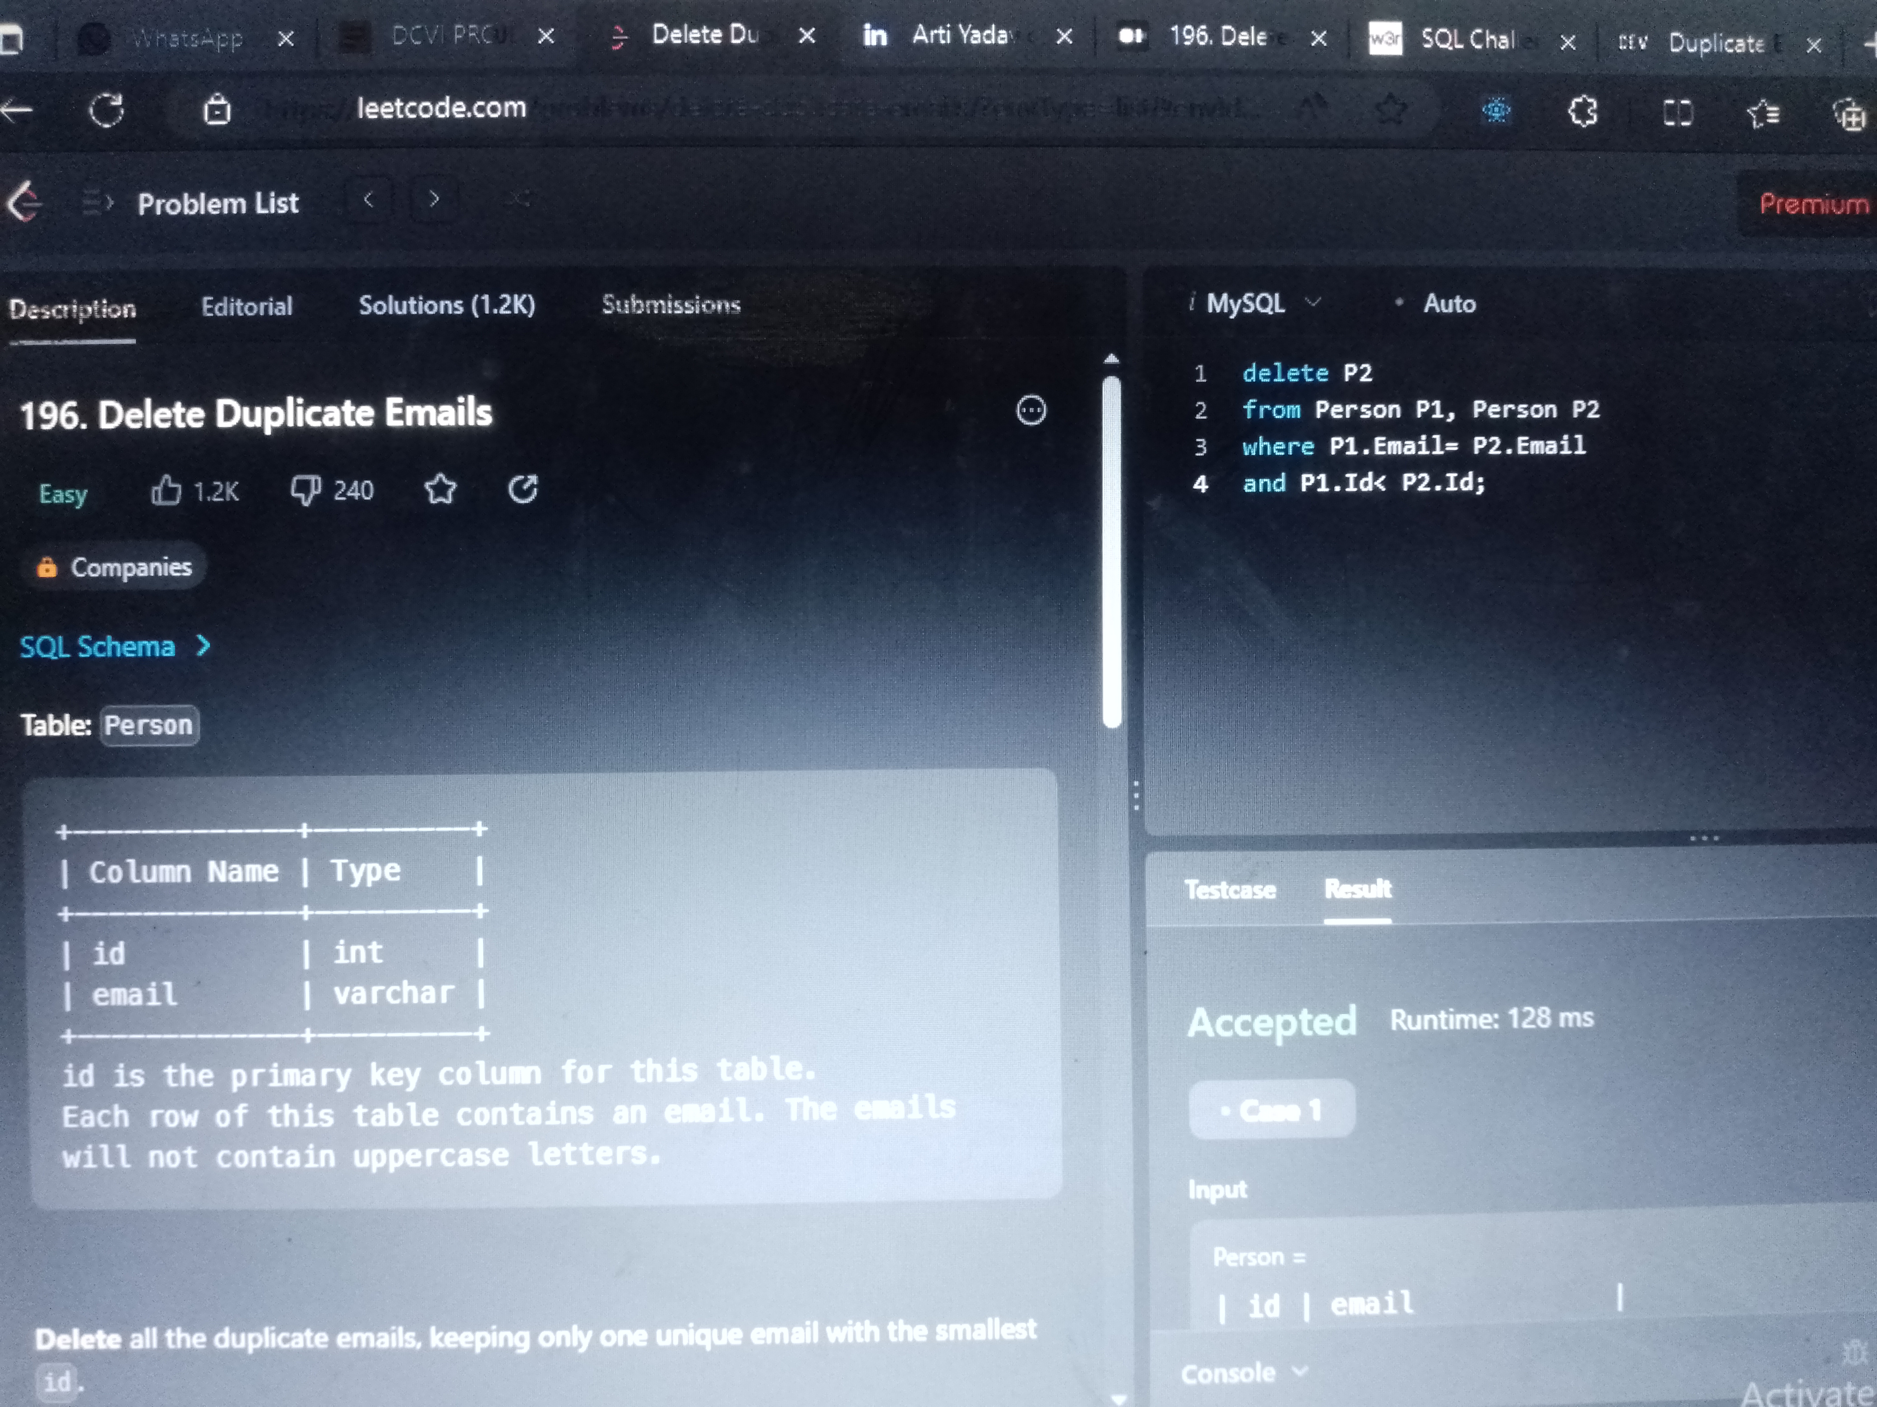

3• https://leetcode.com/problems/customers-who-never-order/?envType=list&envId=e97a9e5m

Answer:

SELECT Name as Customers FROM Customers

LEFT JOIN Orders

ON Customers.Id = Orders.CustomerId

WHERE Orders.CustomerId IS NULL;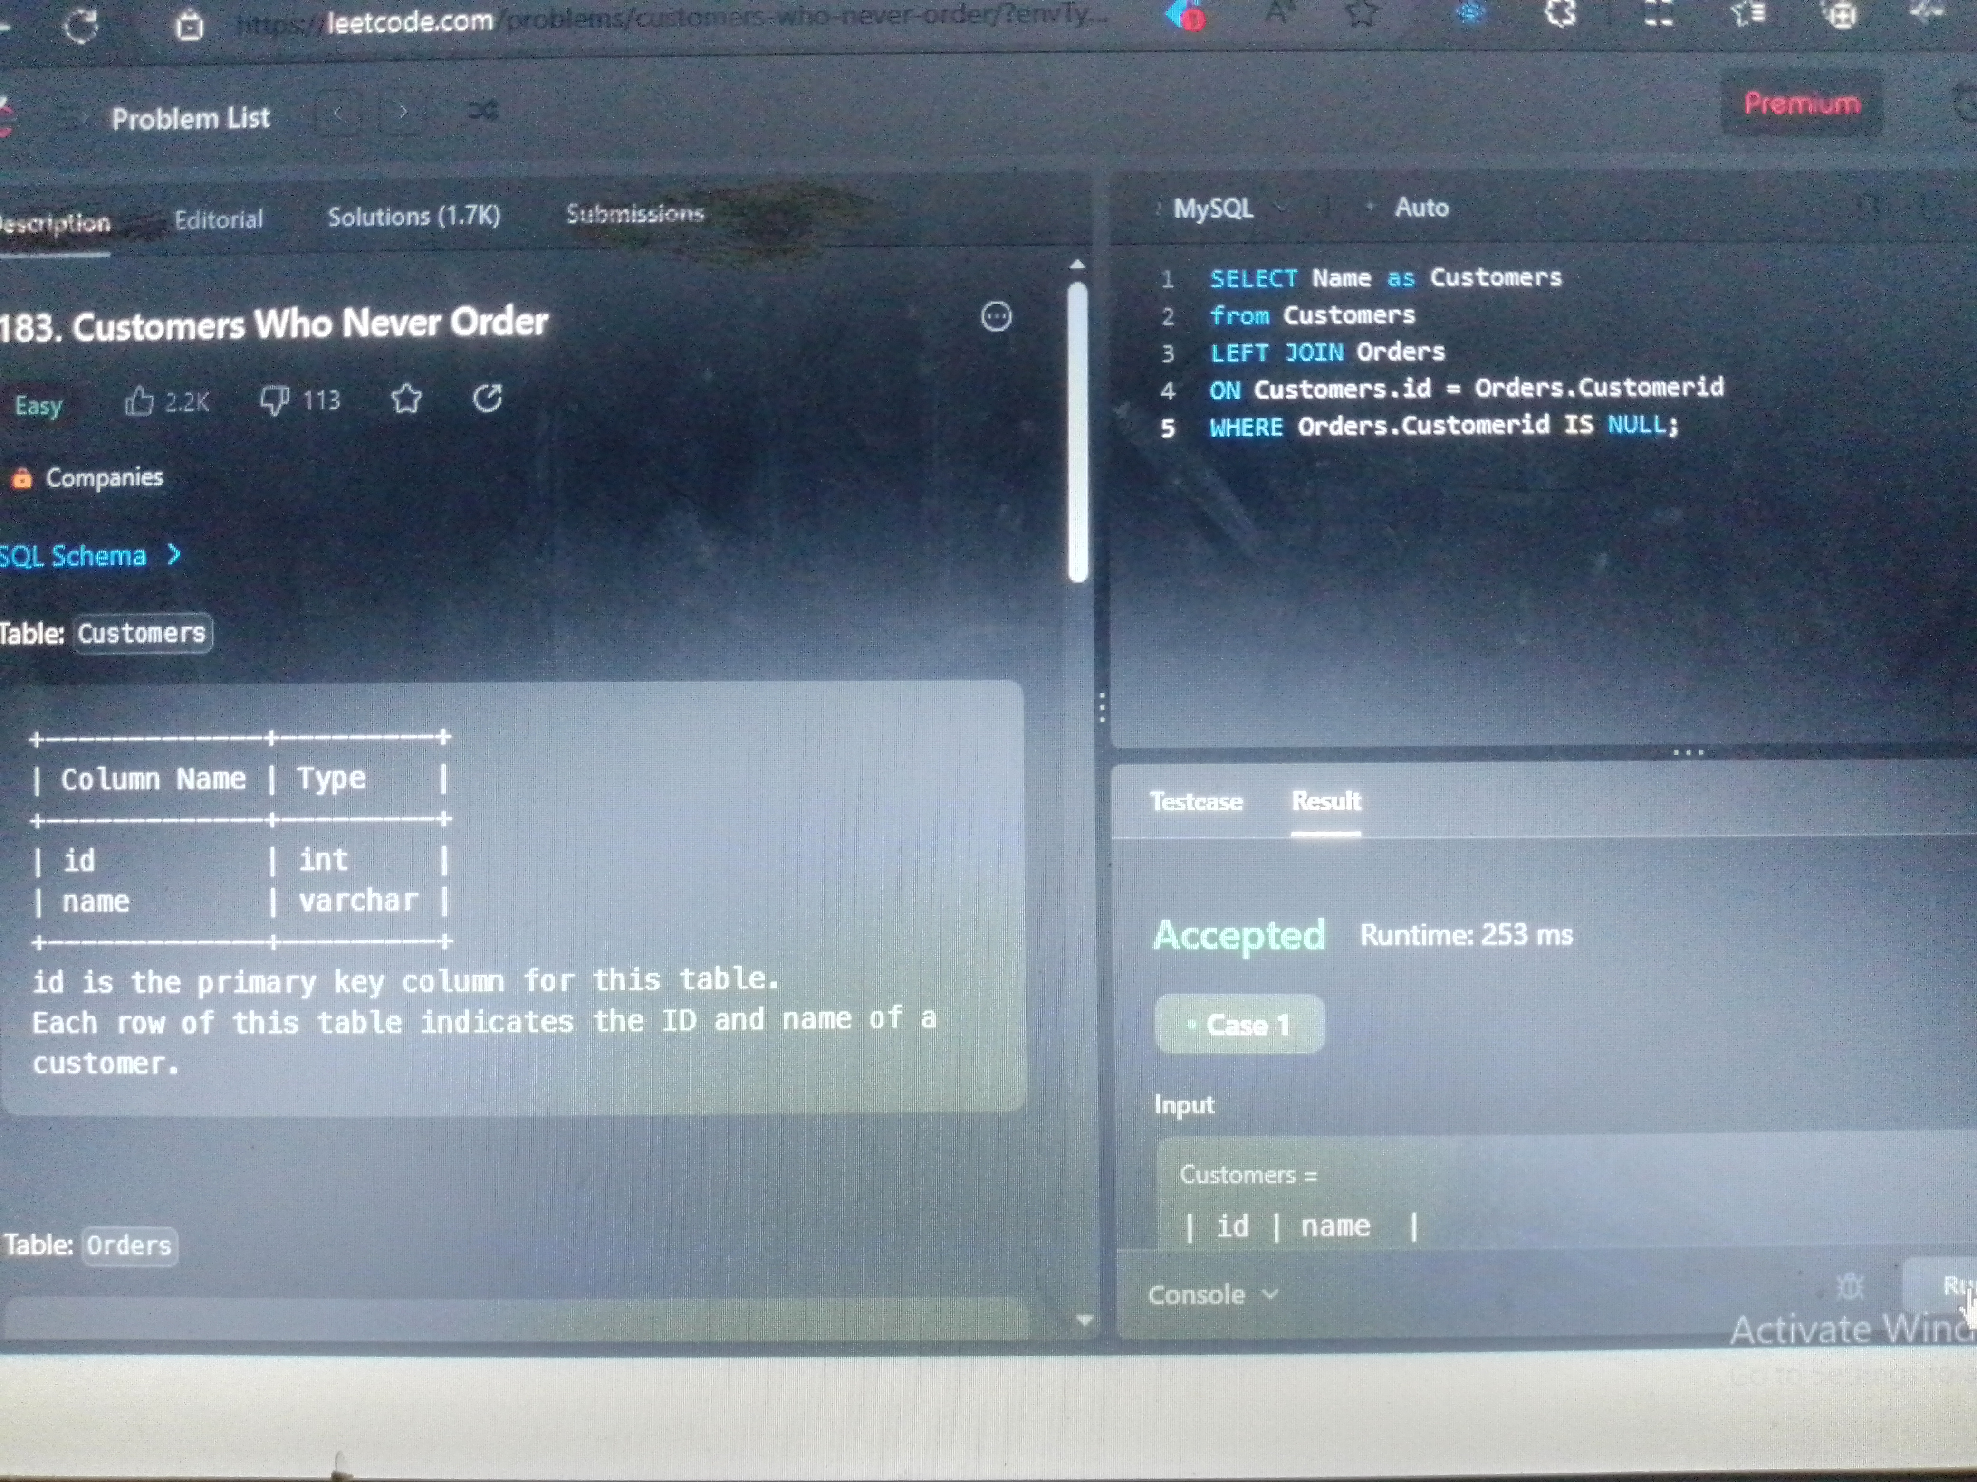

4• https://leetcode.com/problems/daily-leads-and-partners/?envType=list&envId=e97a9e5m

Answer:

SELECT date_id, make_name,

COUNT(distinct lead_id) as unique_leads,

COUNT(distinct partner_id) as unique_partners

FROM DailySales

GROUP BY date_id, make_name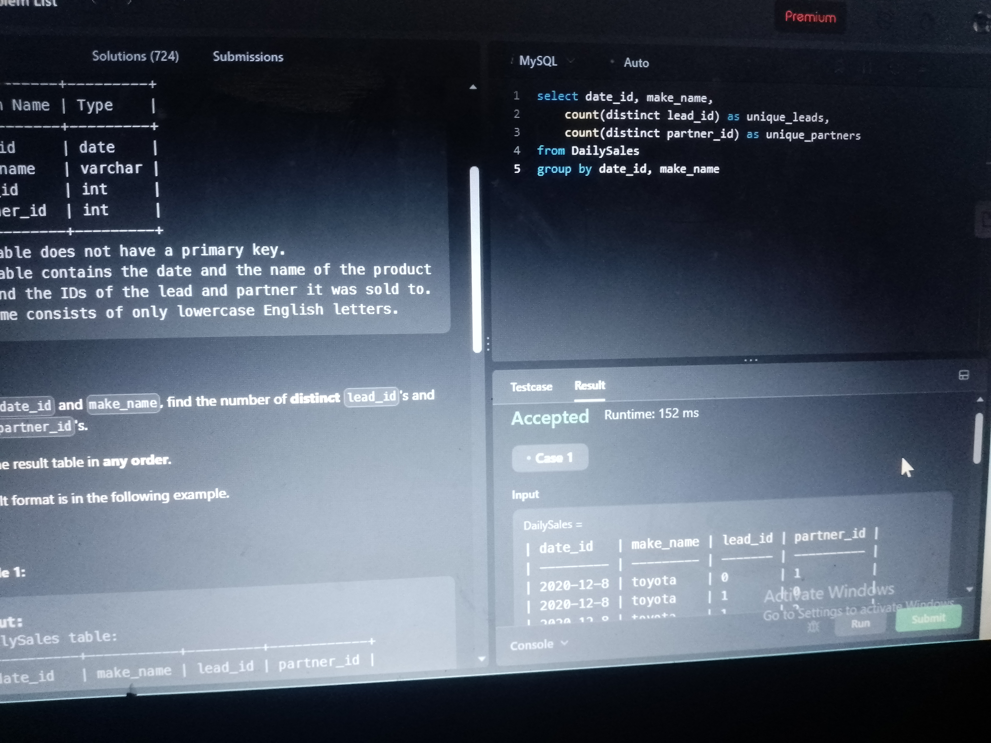

5• https://leetcode.com/problems/user-activity-for-the-past-30-days-i/?envType=list&envId=e97a9e5m

Answer:

SELECT activity_date as day, COUNT(distinct(user_id)) as active_users FROM Activity

WHERE activity_date between “2019-06-28” AND “2019-07-27”

GROUP BY activity_date;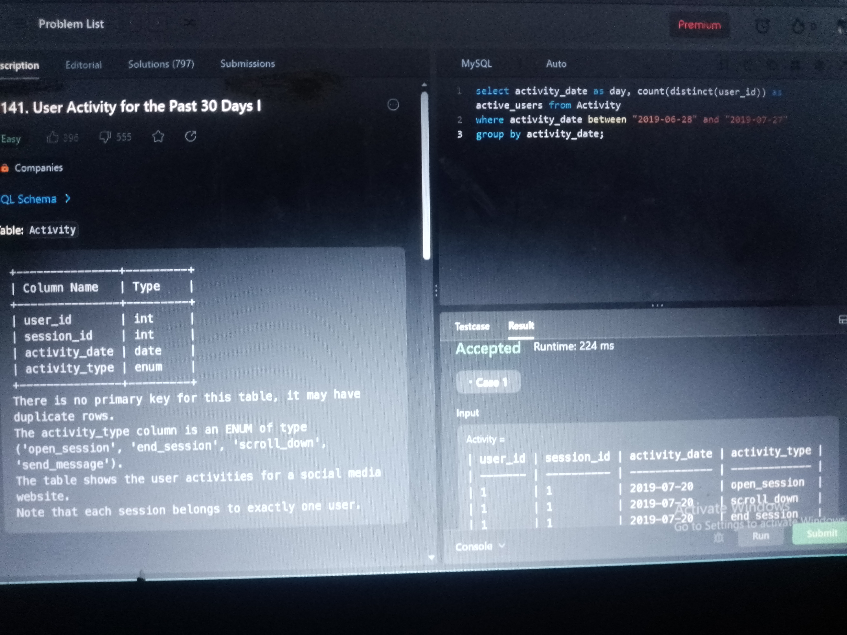

6• https://www.hackerrank.com/challenges/15-days-of-learning-sql/problem?isFullScreen=true

Answer:

SELECT submission_date, (SELECT COUNT(DISTINCT hacker_id)

FROM Submissions AS SUB2

WHERE SUB2.submission_date = SUB1.submission_date AND

(SELECT COUNT(DISTINCT submission_date)

FROM Submissions AS SUB3

WHERE (SUB3.hacker_id = SUB2.hacker_id) AND (SUB3.submission_date < SUB1.submission_date)) = DATEDIFF(SUB1.submission_date, ‘2016-03-01’ )), (SELECT hacker_id FROM Submissions SUB4

WHERE SUB4.submission_date = SUB1.submission_date

GROUP BY hacker_id

ORDER BY COUNT(submission_id) DESC, hacker_id LIMIT 1) AS HID, (SELECT name FROM Hackers WHERE hacker_id = HID)

FROM (SELECT DISTINCT(submission_date)

FROM Submissions) AS SUB1